Create project

* Create a board like scrum or agile
* Azure Repos
* Git workflows

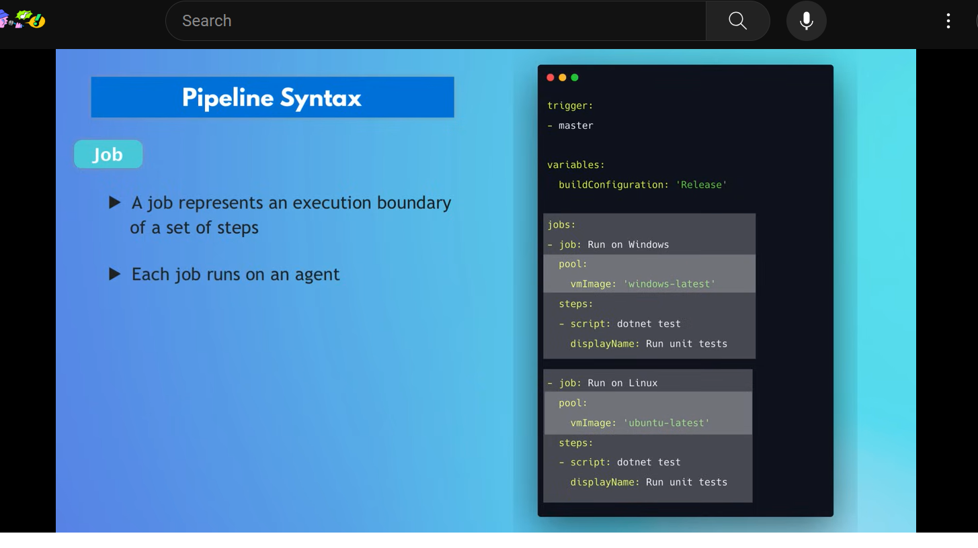

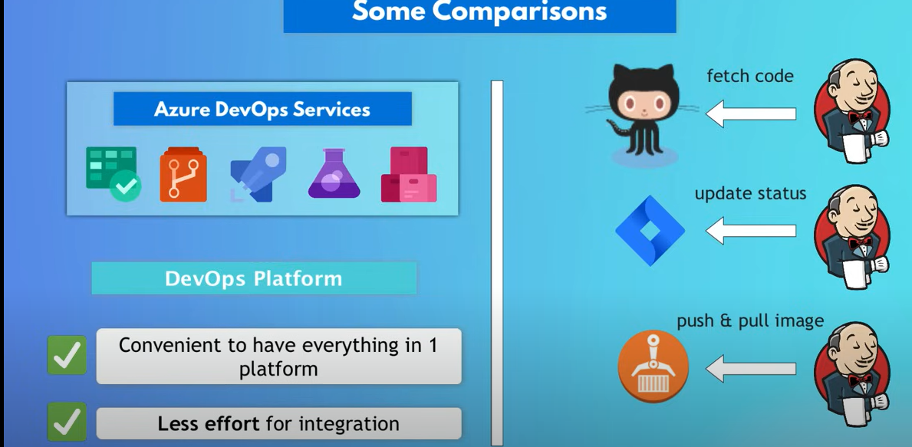

Date: 16/12/23

Azure Devops:

In Azure devops let’s start with creating Agile project

* Once you login to the azure devops portal
* Create a Agile project( here we have options to create type of project(**work item process**) we want to create like Agile/Scrum/CMMI/basic )
* After that you can create azure board
* After that you can create epic under azure board
* Under epic you can create User Stories US
* Under US you can create Tasks
* This the hirearchy Organization > Project(agile) > Azure board > Epic > US > Tasks
* And creating sprints and adding required backlog task to the sprint
* All these you can see dashboard(kanban dashboard)

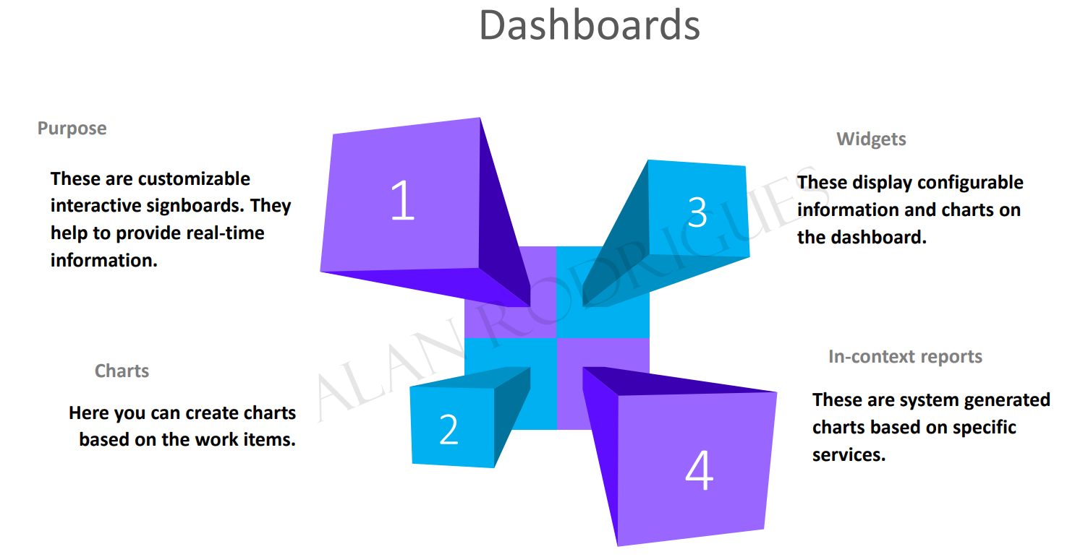

* We can assign users to the tasks

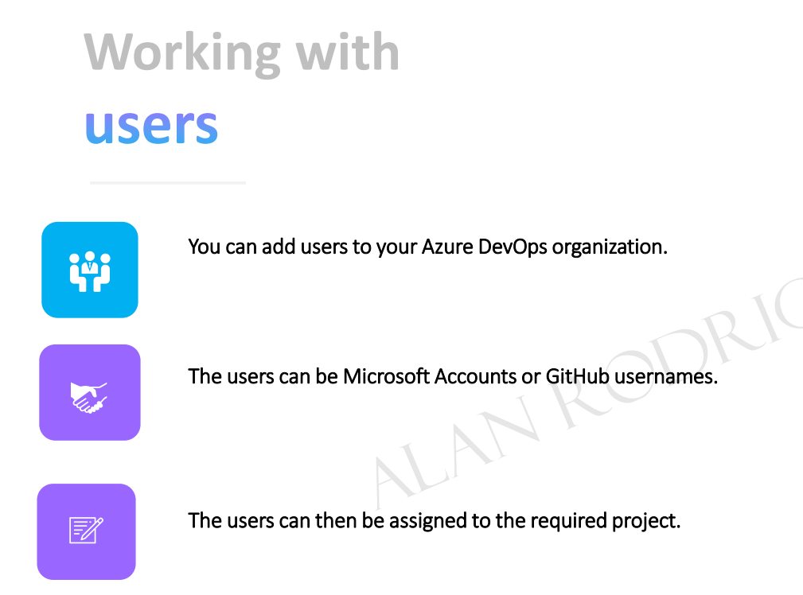

* We have permissions assigned to users by adding them to security groups like “contributer/build administrators/ project administrators/ project valid users/ readers/ release administrators”(permissions can be assigned at organization/project/object level)
* 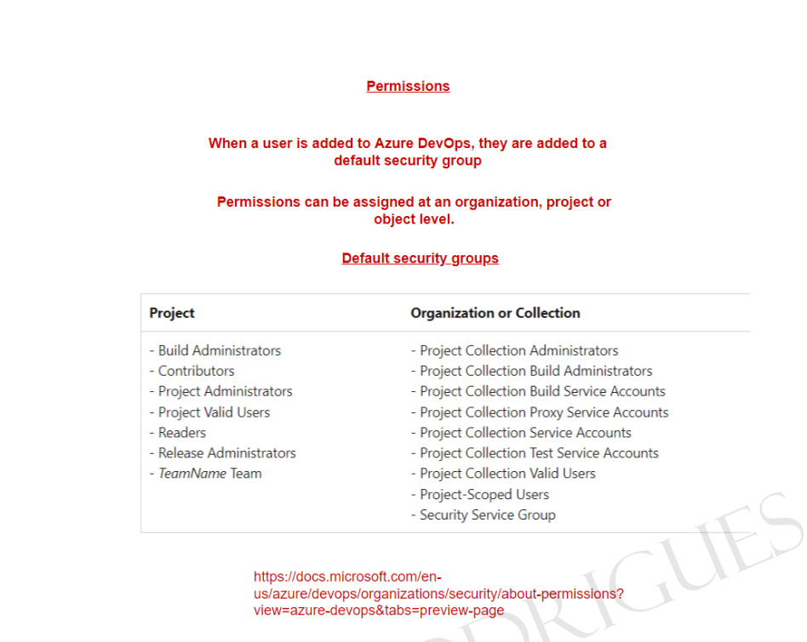

Azure Repos:

* In Azure DevOps Structure look like Organization > Project > Azure Repos
* GitHub repos can be imported to Azure Repos by using PAT(Personal Access Token)
* Azure Repos Branch policy (Assigning minimum Reviewers for PR request)
* Azure Repos Branch policy for work items (Assigning User Stories/ Tasks for PR requests)
* Azure Repos Branch Security (Setting user permissions like “Build Administrators”, “Contributors” and “Project Administrators” and policies like “Commit author email validation” and “file path validation” in terms of blocking pushes if patters does not match)
* .gitignore file is used to untrack specific files from tracking versions, for this you just add that file name in this .gitignore file